ENZYME KINETICS I
Introduction: Enzyme kinetics is the study of the rates of enzyme-catalysed reactions and its role in metabolism. It also involves how the activity of the enzyme is controlled in the cell and how some substances can inhibit its activity. The reaction is measured and the effects of varying conditions of the reaction are investigated.
The mode of action of the enzymes is summarized by the following equation:
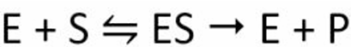
E is the enzyme, S is the substrate, and P is the product formed. This equation shows that an enzyme and a substrate bind to form an enzyme-substrate complex (ES). This complex then produces the product. As the enzyme is released at the end and not used up in the reaction, it is a catalyst.

Enzyme Activity
This can be defined as the amount of enzyme required to convert 1µmol of substrate to product per minute under specified assay conditions.
1U-1micromole/minute. This is the international unit. The SI unit of enzyme activity is the Katal, defined as the amount of enzyme required to convert 1mol of substrate to product per second.
1U= 1.67X 10⁻⁸K = 16.7nK

Specific Activity: This is defined as the number of enzyme units per milligram of protein (µmol/min/mg).
Turnover number: This is equal to the units of activity per mole of enzyme. Also called the catalytic enzyme, it allows for direct comparison of catalytic ability between enzymes e.g. the constants for catalase and α-amylase are 5 X 10⁶ and 1.9 X 10⁴, respectively. This indicates that catalase is about 2,500 times more active than α-amylase.
Maximum velocity: This is the velocity obtained under conditions of substrate saturation of the enzyme and specified conditions of pH, temperature and ionic strength. Vmax is a constant for a given enzyme.

Mechanism of Enzyme Reaction
Any two molecules have to collide for the reaction to occur along with the right orientation and a sufficient amount of energy. The energy between these molecules needs to overcome the barrier in the reaction. This energy is called activation energy.
Enzymes are said to possess an active site. The active site is a part of the molecule that has a definite shape and the functional group for the binding of reactant molecules. The molecule that binds to the enzyme is referred to as the substrate group. The substrate and the enzyme form an intermediate reaction with low activation energy without any catalysts.

Models of Enzyme-Substrate Interactions
1. Lock-and-Key Model
- Concept: This model, proposed by Emil Fischer in 1894, suggests that the enzyme's active site is a rigid, specific shape (the "lock") that perfectly fits the substrate (the "key").
- Limitation: It doesn’t account for the flexibility of enzymes or the induced conformational changes during catalysis.
2. Induced Fit Model
- Concept: Proposed by Daniel Koshland in 1958, this model describes the active site of the enzyme as flexible, not rigid. Upon substrate binding, the enzyme undergoes a conformational change that allows the substrate to fit more tightly into the active site.
- Advantage: This model explains how enzymes can accommodate substrates with slight variations in shape and provides a more dynamic view of catalysis.
3. Transition State Theory
- Concept: This theory focuses on the fact that enzymes lower the activation energy required for a reaction by stabilizing the transition state — an intermediate state during the reaction. Enzymes provide an environment that is optimal for forming this high-energy, unstable transition state, thereby speeding up the reaction.
- Advantage: It explains the mechanistic details of how enzymes accelerate reactions.
4. Michaelis-Menten Model
- Concept: This model provides a quantitative framework for enzyme kinetics. It describes how enzyme activity depends on the concentration of substrate and is based on the formation of an enzyme-substrate complex (ES) that converts into the product.
5. Allosteric Models
- Concept: Some enzymes are regulated through allosteric sites, where the binding of an effector molecule at a site other than the active site induces a conformational change. This can either enhance (activator) or inhibit (inhibitor) the enzyme's activity.
- Monod-Wyman-Changeux (MWC) Model: This model proposes that enzymes exist in an equilibrium between active (R state) and inactive (T state) forms, and allosteric effectors shift the equilibrium.
- Sequential Model: In contrast to the MWC model, this model suggests that enzyme subunits change conformation sequentially upon binding substrates or effectors, allowing for more nuanced regulation.

6. Energy Landscape Model
- Concept: This is a more advanced model that views enzyme-substrate interactions as occurring on a complex "energy landscape," where enzymes navigate through various conformational states. This model emphasizes the dynamic, multi-step nature of enzyme catalysis.

There are four possible major mechanisms of catalysis:
Catalysis by Bond Strain
The induced structural rearrangements in this type of catalysis produce strained substrate bonds that attain transition state more easily. The new conformation forces substrate atoms and catalytic groups like aspartate into conformations that strain substrate bonds.
Covalent Catalysis
The substrate is oriented to active place on the enzymes in such a manner that a covalent intermediate develops between the enzyme and the substrate, in catalysis that occurs by covalent mechanisms. The best example of this involves proteolysis by serine proteases that have both digestive enzymes and various enzymes of the blood clotting cascade. These proteases possess an active site serine whose R group hydroxyl generates a covalent bond with a carbonyl carbon of a peptide bond and results in the hydrolysis of the peptide bond.
Catalysis Involving Acids and Bases
Other mechanisms add to the completion of catalytic events which are launched by strain mechanisms such as the usage of glutamate as a general acid catalyst.
Catalysis by Orientation and Proximity
Enzyme-substrate interactions induce reactive groups into proximity with one another. Also, groups like aspartate are chemically reactive, and their proximity towards the substrate favours their involvement in catalysis.
Michaelis-Menten Rate Equation
In 1903, French chemist Henri found that enzyme kinetics was initiated by a bond between enzyme and substrate. His work was taken up by Leonor Michaelis and Maud Menten. They proposed a mathematical model of the reaction. It involves an enzyme E binding to a substrate S to form a complex ES, which in turn is converted into a product P represented as follows:
S + E ↔ ES → P + E
The Michaelis-Menten equation is a mathematical model that is used to analyze simple kinetic data. The model has certain assumptions, and as long as these assumptions are correct, it will accurately model your experimental data. It makes the following assumptions:
Assumption #1:
- There is no product present at the start of the kinetic analysis
- Therefore, as long as we monitor initial reaction rates we can ignore the reverse reaction of E+P going to ES
Assumption #2:
- During the reaction an equilibrium condition is established for the binding and dissociation of the Enzyme and Substrate (Briggs-Haldane assumption)
- Thus, the rate of formation of the ES complex is equal to the rate of dissociation plus breakdown
Assumption #3:
[E] << [S]
- The enzyme is a catalyst, it is not destroyed and can be recycled, thus, only small amounts are required
- The amount of S bound to E at any given moment is small compared to the amount of free S
- It follows that [ES] << [S] and therefore [S] is constant during the course of the analysis NOTE: this assumption requires that the reaction is monitored for a short period, so that not much S is consumed and [S] does not effectively change.
Assumption #4:
- Only the initial velocity of the reaction is measured
- [P] = 0 (reverse E + P reaction can be ignored)
- [S] » [S]_{initial}

Assumption #5:
- The enzyme is either present as free enzyme or as the ES complex
- [E]total = [E] + [ES]

The equation is:
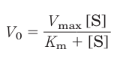
The important terms are [S], V₀, Vmax, and a constant called the Michaelis constant, Km. All these terms are readily measured experimentally.
Here we develop the basic logic and the algebraic steps in a modern derivation of the Michaelis-Menten equation, which includes the steady-state assumption introduced by Briggs and Haldane. The derivation starts with the two basic steps of the formation and breakdown of ES. Early in the reaction, the concentration of the product, [P], is negligible, and we make the simplifying assumption that the reverse reaction, P → S (described by k-₂), can be ignored. This assumption is not critical but it simplifies our task. The overall reaction then reduces to:
Equation 1
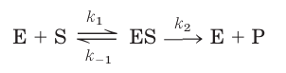
Equation 2
V₀ is determined by the breakdown of ES to form product, which is determined by [ES]:
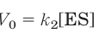

Because [ES] in Equation above is not easily measured experimentally, we must begin by finding an alternative expression for this term. First, we introduce the term [Et], representing the total enzyme concentration (the sum of free and substrate-bound enzyme). Free or unbound enzyme can then be represented by [Et] - [ES].
Also, because [S] is ordinarily far greater than [Et], the amount of substrate bound by the enzyme at any given time is negligible compared with the total [S]. With these conditions in mind, the following steps lead us to an expression for V₀ in terms of easily measurable parameters.

Rate of ES formation = k₁[E][S] + k₋₂[E][P]
Assumption #1 says we can ignore the k₋₂ reaction, therefore:
Rate of ES formation = k₁[E][S]
Assumption #5 says [E] = [E]_{total} - [ES], therefore:
Rate of ES formation = k₁([E]_{total} - [ES])[S]
The rate of ES breakdown is a combination of the dissociation and the conversion to product:
Rate of ES breakdown = k₋₁[ES] + k₂[ES]
Rate of ES breakdown = (k₋₁ + k₂)[ES]
Assumption #2 says the rate of ES formation equals the rate of breakdown:
k₁([E]_{total} - [ES])[S] = (k₋₁ + k₂)[ES]

Step 1
The rates of formation and breakdown of ES are determined by the steps governed by the rate constants k₁ (formation) and k₋₁+ k₂ (breakdown), according to the expressions:
Rate of ES formation k₁([Et] - [ES])[S]
Rate of ES breakdown k₁[ES] + k₂[ES]

Step 2
We now make an important assumption: that the initial rate of reaction reflects a steady state in which [ES] is constant—that is, the rate of formation of ES is equal to the rate of its breakdown. This is called the steady-state assumption. The expressions in Equations in step 1 can be equated for the steady state, giving:
k₁([Et] - [ES])[S] = k-₁[ES] + k₂[ES]

Step 3
In a series of algebraic steps, we now solve Equation above for [ES]. First, the left side is multiplied out and the right side simplified to give:
k₁[Et][S] – k₁[ES][S] = (k₋₁ + k₂)[ES]

Adding the term k₁[ES][S] to both sides of the equation and simplifying gives:
k₁[Et][S] = (k₁[S] + k₋₁ + k₂)[ES]
We then solve this equation for [ES]:
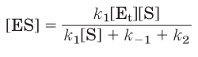
This can now be simplified further, combining the rate constants into one expression:
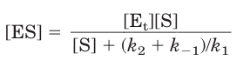
The term (k₂ + k₋₁)/k₁ is defined as the Michaelis constant, Km. Substituting this into Equation above simplifies the expression to:
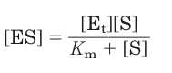

Step 4
We can now express V₀ in terms of [ES]. Substituting the right side of Equation above for [ES] in Equation 2 above (shown before deriving) gives:
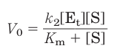
This equation can be further simplified. Because the maximum velocity occurs when the enzyme is saturated (that is, with [ES] = [Et]) Vmax can be defined as k₂[Et]. Substituting this in Equation above gives Equation 1 (shown above before deriving):
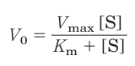
This is the Michaelis-Menten equation, the rate equation for a one-substrate enzyme-catalyzed reaction. It is a statement of the quantitative relationship between the initial velocity V₀, the maximum velocity Vmax, and the initial substrate concentration [S], all related through the Michaelis constant Km. Note that Km has units of concentration.

Consider the Michaelis-Menten equation under 3 different conditions:
1. When Km>>>[S],
The equation becomes V= Vmax[S]/ Km, V= (Vmax/Km) [S]
This implies that at low substrate concentrations, the rate is directly proportional to [S]

2. When Km = [S]
V= Vmax[S]/2[S] or v= Vmax/2. i.e Km is the substrate concentration at which we have half the maximum velocity.

3. When Km<<<[S]
V= Vmax i.e at high [S], v= Vmax.

Linear Forms of the Michelis-Menten Equation
The linear form of the equation is
1/V= Km/Vmax[1/S] + 1/Vmax
A plot of 1/V vs 1/[S] yields a straight line whose slope is Km/Vmax and whose y-intercept is 1/Vmax. The intercept on X-axis is -1/Km.
This linear form is called the theLineWeaver-Burk equation and the plot the Lineweaver-Burk plot. It can be used to obtain values of the kinetic parameters for a given enzyme reaction.
Km is an indication of the affinity of the enzyme for its substrate. Low Km indicates high affinity and vice versa.
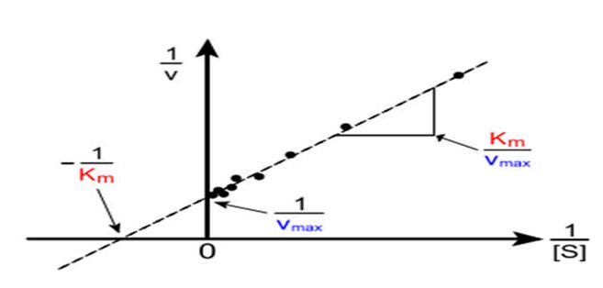
Figure 1: Lineweaver-Burk plot.
Other linear forms of the M.M equation are the Eadie-Hofstee equation and the Woolf equation.
Eadie-Hofstee; V= -Km. V/[S] + Vmax
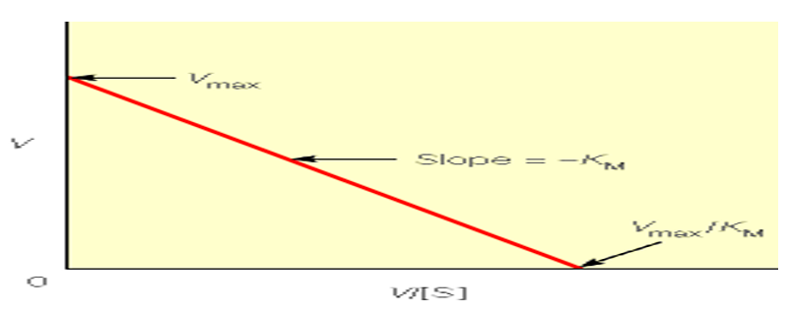
Figure 2: Eadie-Hofstee Plot.

Woolf; [S]/V= 1/Vmax.[S] +Km/Vmax
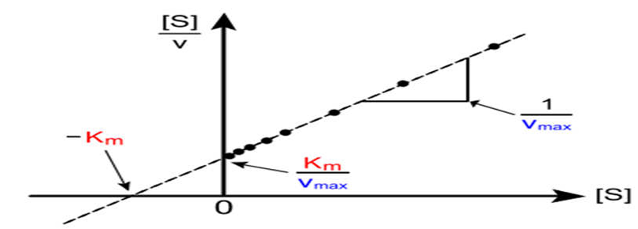
Figure 3: Woolf Plot.

